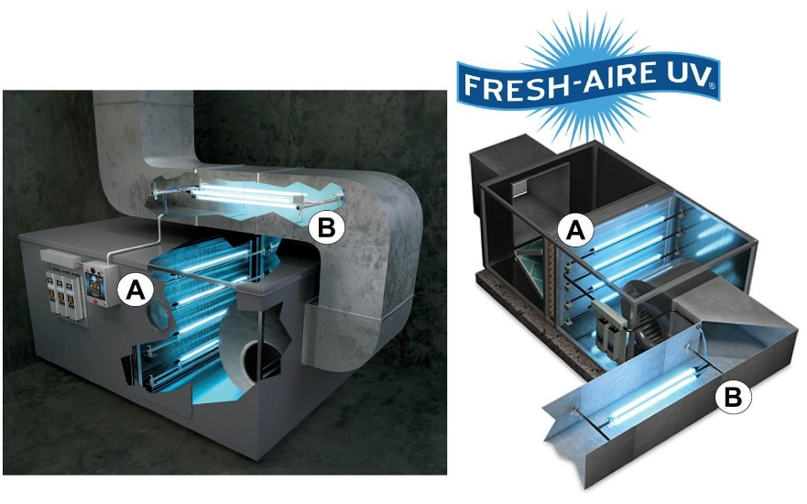
FRESH-AIRE UV COMMERCIAL SIZING SURVEY
Fresh-Aire UV has two HVAC disinfection options. Learn more below.
Option A) coil/air handler disinfection, which is ideal for maintaining a clean coil, drain pan and surfaces within the AHU addressing any biological blow-off and all-around air treatment. You would provide the size of the coil. Fresh-Aire UV also offers systems for high-level air disinfection option B) which are parallel lamp systems that are mounted in the return or supply that provides a higher level of airstream disinfection. These are typically used in healthcare applications such as operating and patient rooms.
If you are looking for airstream disinfection we can size the lamp systems for the coil/air handler (option A) and can “oversize” so we can also address the moving air better, or should you wish, please provide the duct dimensions (return or supply) and CFM and we can base our sizing calculations on our ADS system (option B). Send sizing survey to john@battscan.ca or call 519-856-1380 For more information visit www.FreshAireUV.com.
Project Name ____________________________________ Company Name __________________________Date________________
Unit Number and Unit location_____________________________ Wholesaler Info _______________________________________
Jobsite Contact________________________________ Application (i.e. hospital, school, agriculture)__________________________
**PHOTOS REQUESTED IF AVAILABLE**
- AHU TYPE: ______ DX _____Chilled water _____Roof Top Package unit
- AHU INFO: MAKE _________________ Model # _________________ CFM ____________
- COIL SIZE: (Measured in ____ Inches ____Centimeters) ________Wide x _______ High Coil Depth __________
- STACKED COILS? _______ CENTER DRAIN PAN ? _________ Coil Coating? YES NO
- VOLTAGE: _____120VAC _____208/230VAC _____277VAC _____ 460/480VAC
- BELTS/ WIRES/RUBBER / FILTERS NEAR COIL? _____ YES _____ NO
- COIL / BLOWER DISTANCE: ______________
- COIL CONDITION:_____CLEAN _____DIRTY Comments: ________________________________
- INSTALL BY: ______INHOUSE _____CONTRACTOR
- CURRENTY USING UVC PRODUCTS? YES NO Manufacturer: _________________________
- INTERESTED IN: ______ COIL CLEAN _____ ODOR CONTROL _____AIRBORNE DISINFECTION
- IF INTERESTED IN AIRBORNE DISINFECTION, PLEASE PROVIDE:
DUCT SIZE: ______Wide x ______High DUCT Length: ______ DUCT MATERIAL: ____________
